ESP8266 Wi-Fi Integrated Module + Circuit Explanation
The ESP8266 is an ultra-low-power UART-to-Wi-Fi transparent transmission module. It features a highly competitive package size and ultra-low power consumption technology. It is designed specifically for mobile devices and Internet of Things applications. It can connect a user's physical device to a Wi-Fi wireless network for Internet or local area network communication, thereby enabling networking functions.
The ESP8266 is available in multiple package forms, and its antenna can be a PCB onboard antenna, an IPEX interface, or a castellated-hole interface.
The ESP8266 can be widely used in smart grids, intelligent transportation, smart home devices, handheld equipment, industrial control, and other fields.
I. Module Features
(1) Supports the 802.11 b/g/n wireless standard
(2) Supports three operating modes: STA/AP/STA+AP
(3) Built-in TCP/IP protocol stack and supports multiple TCP client connections
(4) Supports rich Socket AT commands
(5) Supports UART/GPIO data communication interfaces
(6) Supports Smart Link networking
(7) Supports remote firmware upgrade (OTA)
(8) Built-in 32-bit MCU, which can also serve as an application processor
(9) Ultra-low power consumption, suitable for battery-powered applications
(10) Single 3.3V power supply
II. Main Functions of the ESP8266: UART transparent transmission, PWM control, and GPIO control.
(1) UART transparent transmission: reliable data transmission, with a maximum transmission rate of 460800 bps.
(2) PWM control: lighting adjustment, RGB LED adjustment, motor speed control, etc.
(3) GPIO control: control of switches, relays, etc.
III. Operating Modes
The ESP8266 module supports three operating modes: STA, AP, and STA+AP.
(1) STA mode: the ESP8266 module connects to the Internet through a router, and a mobile phone or computer can remotely control the device through the Internet.
(2) AP mode: the ESP8266 module acts as a hotspot, allowing a mobile phone or computer to communicate directly with the module for local wireless control.
(3) STA+AP mode: coexistence of the two modes, enabling Internet control and seamless switching for convenient operation.
IV. Application Areas
(1) CH340 serial-to-Wi-Fi conversion;
(2) Industrial transparent transmission DTU;
(3) Wi-Fi remote monitoring/control;
(4) Toys;
(5) RGB LED control;
(5) Integrated intelligent management for fire protection and security;
(6) Smart card terminals, wireless POS machines, Wi-Fi cameras, handheld devices, etc.
V. Module Interface Description
(1) RXD: serial input, TTL level
(2) TXD: serial output, TTL level
(3) GND: connect to GND
(4) VCC: connect to 5V
The ESP8266 module is used together with a serial output baseboard. The baseboard includes a power chip and an onboard AMS1117-3.3V voltage regulator. The AMS1117-3.3 chip steps down the 5V DC voltage to 3.3V to supply power to the ESP8266 module circuit in the system. The internal circuit diagram of the serial output board is shown below:
Baseboard schematic
The schematic interface diagram of the Wi-Fi integrated module is shown below.
Schematic interface diagram of the Wi-Fi integrated module
The physical picture of the Wi-Fi integrated module is shown below.
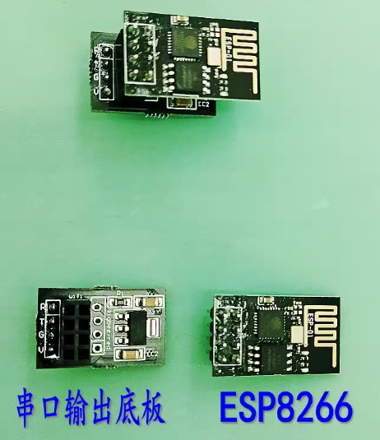
Physical picture of the Wi-Fi module

